**RUBY ON RAIL ASSIGNMENT-1**

**1)A Good First Program(Ex1.rb)**

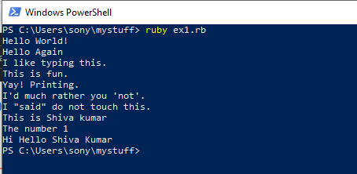

**2)Comments And Pound Characters(Ex2.rb)**

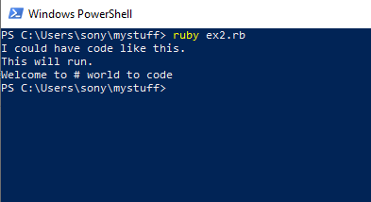

**3)Numbers And Maths(Ex3.rb)**



**4) Variables And Names(Ex4.rb)**

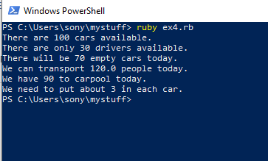

**5)More Variable And printing(Ex5.rb)**

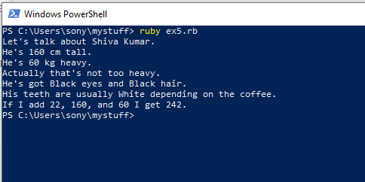

**6)String And Text(Ex6.rb)**

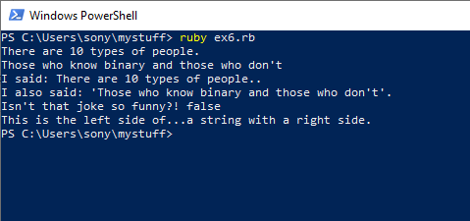

**7)More Printing(Ex7.rb)**

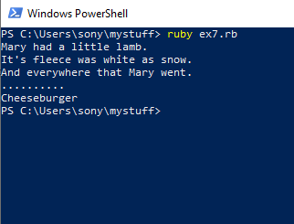

**8)Printing , Printing(Ex8.rb)**

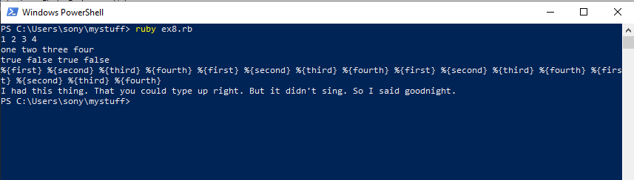

**9)Printing , Printing ,Printing(Ex9.rb)**

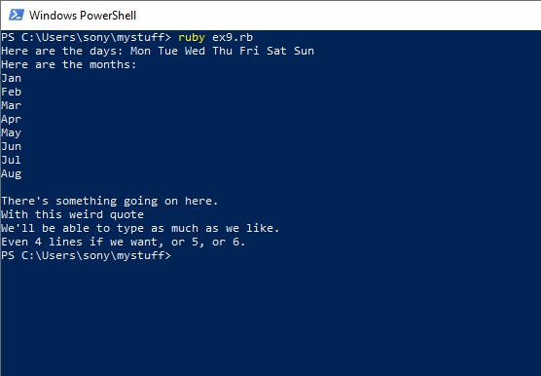

**10)What Was That ?(Ex10.rb)**

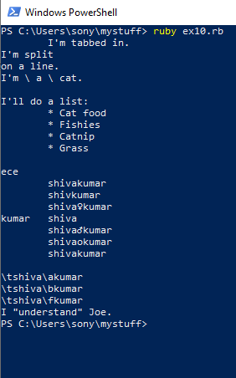

**11)Asking Question(Ex11.rb)**

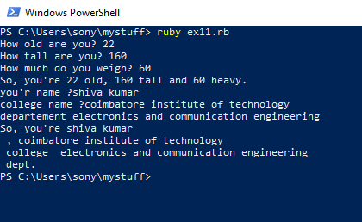

**12)Prompting People(Ex12.rb)**

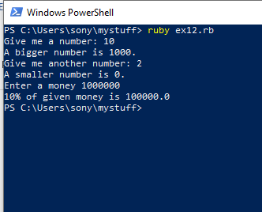

**13)Parameters,Unpacking,Variables(Ex13.rb)**

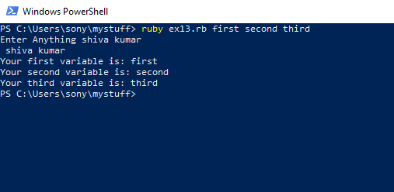

**14)Prompting And Passing(Ex14.rb)**

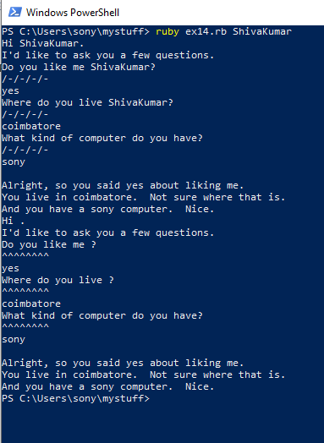

**15)Reading File(Ex15.rb)**

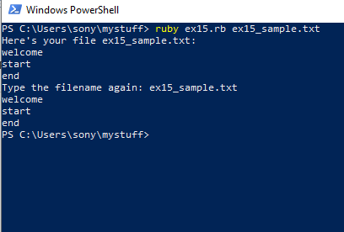

**16)Reading And Writing File(Ex16.rb)**

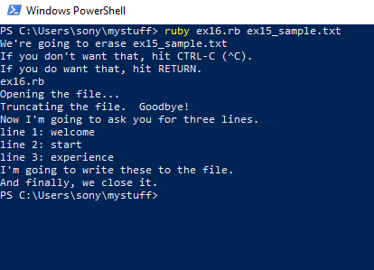

**17)More File(Ex17.rb)**

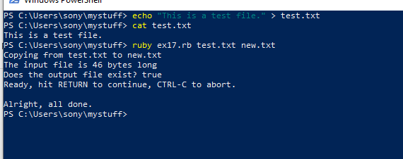

**18)Names,Variables,Code,Function(Ex18.rb)**

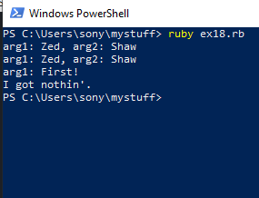

**19)Function And File(Ex19.rb)**

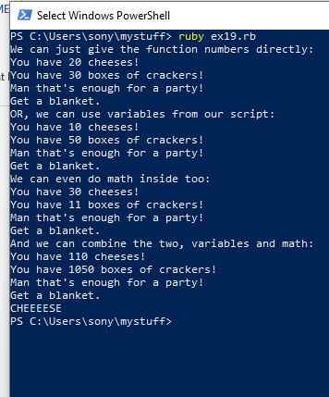

**Function And File(Ex20.rb)**

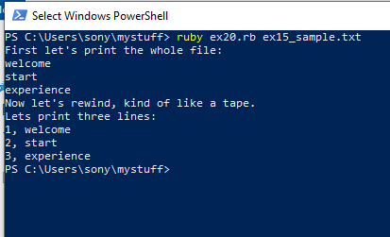

**21)Function Can Return Something(Ex21.rb)**

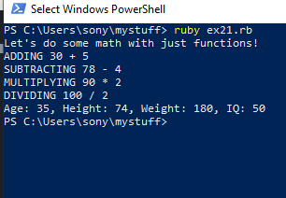

**22)More Practice(Ex24.rb)**

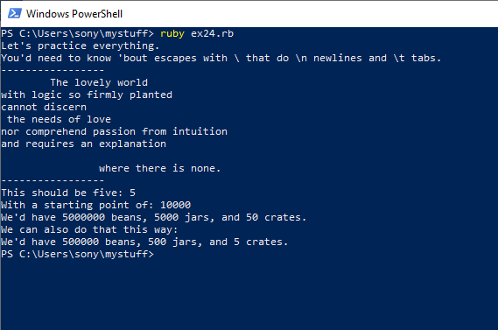

**23)Conguratulation, Take A Test(Ex26.rb)**

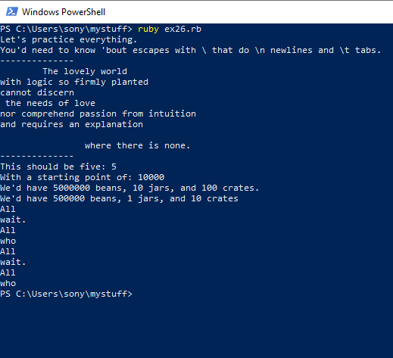

**24)What If(Ex29.rb)**

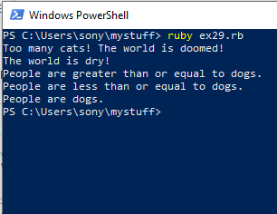

**25)Else And If(Ex30.rb)**

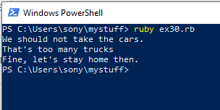

**26)Making Decision(Ex31.rb)** 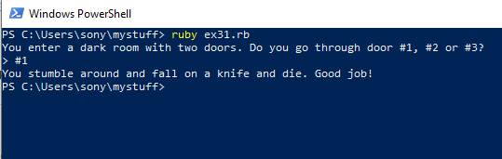

**27)Loop And Array(Ex32.rb)**

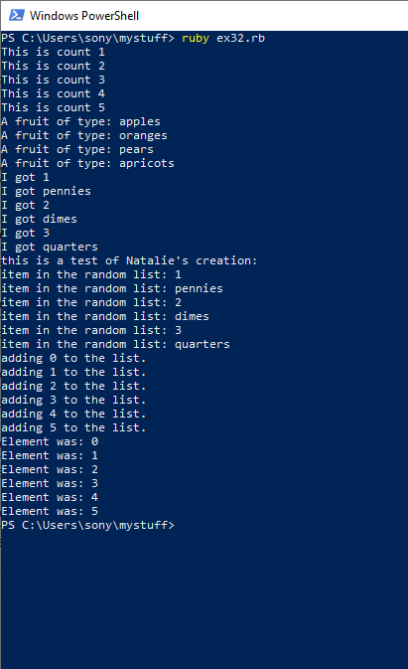

**28)Branches And Functions(Ex35.rb)**

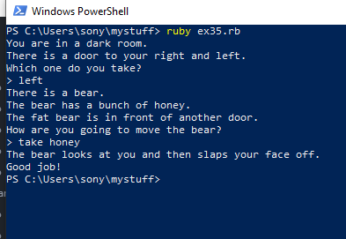

**29)Doing Thing To Array(Ex38.rb)**

